# SIP-00XX: The Sovryn Mynt

## Introduction

Sovryn Mynt is an aggregator protocol for BTC-backed stablecoins. Multiple methods of creating BTC-collateralized tokens, pegged to BTC will be aggregated into a single, ultra-stable coin. For the purposes of this proposal, we will refer to the aggregate coins as "B-Stables". Multiple B-Stables can be created for different pegs. However, initially, it is envisioned that only one peg (possibly to USD) will be chosen.

Mynt will be a Sovryn [subprotocol](https://forum.sovryn.app/t/new-utility-for-sov-minting-subprotocol-tokens/1611), governed by the MYNT token and subordinate to the SOV Bitocracy.

## Motivation

“The root problem with conventional currency is all the trust that’s required to make it work. The central bank must be trusted not to debase the currency, but the history of fiat currencies is full of breaches of that trust.”

— Satoshi Nakamoto

The core mission of Sovryn is to continue Satoshi's mission for establishing new territories of freedom by building trustless economic tools on Bitcoin. Central to accomplishing this mission is to remove the need for intermediaries or the constraints they can impose.

Bitcoin has emerged as a proven store-of-value over long time frames. However, its day-to-day volatility has limited its use as a medium of exchange or for low-risk savings. The Bitcoin whitepaper envisions BTC's use for cash and payments - Sovryn Mynt provides a path to this by overcoming the volatility problem by creating currency whose value can be reliably stable to a given peg. If the peg chosen is a fiat currency, the stablecoin can circulate as a substitute for that currency, unthreatened by need to trust intermediaries and secured by the underlying BTC value.

### Existing Stablecoins are Centralized and Poorly Collateralized

The value and utility of stablecoins has been clearly demonstrated. The many stablecoins on the market have a combined valuation of over $100B USD and are still rapidly growing. The concern with these stablecoins is that they rely on central intermediaries and are backed by collateral that is inferior to BTC. A truly decentralized alternative is needed, and this need is only becoming more urgent as regulatory actions are increasingly threatening the existing stablecoins.

### DoC and other BTC-Backed Stablecoins

A BTC-backed stablecoin already exists in the form of DoC (Dollar on Chain) and has proven to successfully maintain a robust peg. DoC is generated by the MoC (Money on Chain) protocol, which is the second most used protocol on Rootstock after Sovryn. This has demonstrated the desire for BTC-backed stablecoins. What then is the need for Sovryn Mynt?

The Sovryn Mynt will extend and increase the usefulness of DoC, while at the same time improving the resilience of BTC-backed stability and increasing the overall addressable market for B-Stables.

**Multiple Methods of Producing Stability**

There are many methods of producing stable-tokens with collateral. MoC, MakerDAO and RAI are just three examples, and each is of different design, leading to different trade-offs. MoC, for example, allows for atomic (instant) redemption of DoC for BTC, however it also requires a very high level of collateral, making it difficult to scale.

Other methods of generating stability, such as the proposed Sovryn subprotocol Zero, have different trade-offs. Zero allows for lower collateralization ratios and also for 0% interest loans but does not provide for atomic redemptions in the same way (instant redemptions are possible with a variable redemption fee).

The most important difference between the Zero and MoC is that Zero allows for stables to be generated via loans, whereas with DoC is created via a conversion (a sale of BTC).

With Mynt it becomes possible to bundle together these different methods to take advantage of their differing strengths, while at the same time mitigating their weaknesses. This provides for improved peg-stability, greater scale, more unique products and an overall greater market.

### Controlling Systemic Risk

Stablecoins, as a form of currency, play a systemically important role in DeFi systems. Due to the fact that they are so central to the workings of these markets, any weaknesses or centralization that characterizes them is introduced into the entire system. Sovryn can mitigate these risks by setting standards for BTC-backed stablecoins and promoting their use in the Sovryn ecosystem.

In order to accomplish this, Sovryn Mynt must be a part of the Sovryn protocol and BTC-backed stablecoins should enter into the ecosystem primarily as part of the Sovryn Mynt aggregated stablecoin. In effect, the Sovryn Mynt becomes the institution through which the Sovryn community is able to set standards for, and promote the use of, BTC-backed stables.

## 

## Aggregating Methods of Stability

Each of the different systems producing stability that are part of the Mynt system produces a token. We will refer to these as "aggregates" since their primary purpose is to act as part of the collateral that will be wrapped into the B-Stable minted by the Mynt. A hypothetical example can be seen in the below diagram.

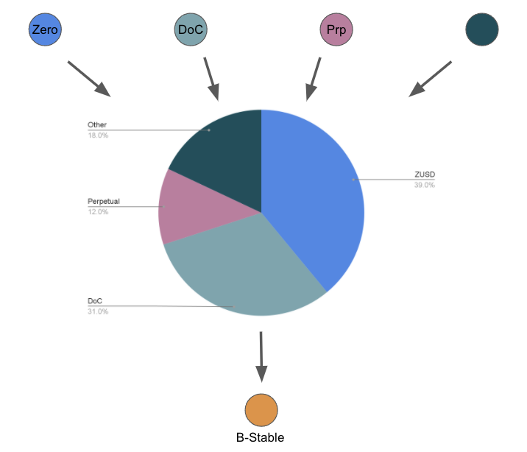

The Mynt can maintain various policies and standards regarding which aggregates are allowed to compose the Mynt pool and what weighting they should have.

## Bootstrapping Mynt and the MYNT token

Ideally, the Mynt would be governed by a sub-DAO, specifically interested and incentivized to focus on the stability, development and promotion of NUE and any related tokens.

For this purpose a 'MYNT' token may act as the governance token for the Sovryn Mynt subprotocol. MYNT tokens will be used to vote on matters such as:

* Which sub-tokens, and therefore which methods of creating BTC-backed stability will be accepted by the Mynt
* System upgrades
* Fees, desired token weightings and other protocol variables

MYNT stakers would play an important role in the Sovryn ecosystem, by setting the standards of collateralization that will be required of BTC-stability protocols for inclusion in the Mynt.

MYNT stakers would then be in a position to benefit from fees generated by the Sovryn Mynt. This revenue may be generated primarily from three types of activity:

1. Trading fees accrued by traders trading one sub-token
2. Redemption fees that may be charged if the stablecoin trades at a premium to its peg
3. Lending of the aggregate tokens, should this activity occur in the future

Additional opportunities for revenue may also arise or be developed.

However, it should be noted that initially the protocol will likely not generate revenue and this revenue might only emerge in the future. It is also possible that such revenue opportunities never emerge.

Without a source of current revenue, there might be incentive misalignment for a separate MYNT Bitocracy. Therefore it might be preferable to have Mynt temporarily governed directly by the SOV Bitocracy. Furthermore, due to the systemic importance of the Mynt, it should always remain subordinate to the SOV Bitocracy - subject to being overruled or halted.

The Mynt system has been developed and will be deployed by a team of developers who have contributed their effort without compensation from the Sovryn exchequer. It is desirable that we should be able to incentivize such efforts in the future, not only for Mynt but for many other sub-protocols as well.

It is therefore proposed that a MYNT token be created, as a SOV-bonded token. A portion of MYNT tokens generated will be directed to a separate Mynt treasury, controlled by MYNT governance, and available to incentivize the future development of the Sovryn Mynt sub-protocol.

It is proposed to allow for a bootstrap event for MYNT to occur on Origins, with the following parameters:

**Bootstrap Event Details**

Bootstrap Supply: 84.25%

Incentive Supply:15.75%

Bootstrap Initial MYNT/SOV ratio: 100/1

|  |  | **Lockup** | **Vesting** |
| --- | --- | --- | --- |
| Bootstrap Supply | 85.25% | 6 weeks | None |
| Incentive Supply | 15.75% | N/A | See Below |
|  |  |  |  |
| **Incentive Supply** |  |  |  |
| Founders (MYNT) | 4% |  | 36 Months, 6 Month Cliff |
| Sovryn core contributors | 0.25% |  | 36 Months, 6 Month Cliff |
| MYNT / BTC AMM | 0.50% | None |  |
| Mynt Treasury | 10% | 1 Month | 36 Months |
| Fully-vested SOV stakers | 1% | Algorithmic | 12 Months |
| **Total** | **15.75%** |  |  |

The Bootstrap event will take place as a week-long event during which SOV can be deposited, via Origins, in the Bootstrap contract and receive MYNT at the initial ratio defined above. The amount that can be deposited will be uncapped. The MYNT will be locked in the depositor’s address until the end of the Bootstrap event.

Notes:

* Founders refers to the contributors who have developed and will deploy the Sovryn Mynt contract
* Sovryn core contributors will receive a small disbursement in light of the assistance that the core team has provided and will likely continue to provide to the Mynt subprotocol.
* Mynt treasury shall unlock over a 3 year period, to provide for development, liquidity mining and other needs perceived by MYNT stakers
* SOV stakers will receive a portion of MYNT tokens as part of their staking revenue over the course of a 1-year period.

## Precautions

Sovryn Mynt is an important protocol for the Sovryn community, Bitcoin and the world. It would be best to see it take on a life of its own, grow and develop. If Sovryn Mynt grows to be a key protocol in the Sovryn ecosystem and the wider stablecoin and economic ecosystem, it may be able to generate substantial revenue.

However, it is also very possible that Sovryn Mynt is extraordinarily successful as a public good, but does not offer opportunities for revenue generation. In such a scenario, it might be best to return the Mynt-bonded SOV to MYNT holders without having to adhere to the bonding curve formula. This orderly wind-down should be available as an option to be voted on by MYNT holders in the future (this is a matter of investigation).

In the event that MYNT governance has not been deployed before the 6 month cliff for Founders and Sovryn Core contributors ends - this vote should be held by the SOV Bitocracy. Under such a circumstance, MYNT token holders should hold a snapshot vote - of which the SOV Bitocracy should vote to uphold the majority view. It must be stressed that this cannot be guaranteed.

In a future scenario, where revenue may be generated from the Mynt, SOV Bitocracy may choose to transfer ownership to MYNT governance such that a portion of Mynt revenue is directed to SOV stakers and/or the Sovryn Exchequer.

To summarize, the MYNT token should currently be viewed as a token for the Sovryn community to Bootstrap the Sovryn Mynt as a public good. There is a desirable but speculative future in which MYNT becomes the governance token for the Mynt sub-DAO, as well as the potential for it to generate revenue at some point in the future, but there should be no expectation that this future will be realized. Contributors to the MYNT Bootstrap event should be aware that their funds may prove to be a donation to this public good and not bear future revenue.

## Resolved

1. The Sovryn Mynt protocol to be deployed, under SOV Bitocracy governance
2. A Bootstrap event to be held on the Origins platform for the MYNT token
   1. Bootstrap + bonding curve parameters and token allocation as per the above